Breathing System

The lungs absorb oxygen from the air and excrete carbon dioxide and water. The air is moistened and warmed as it is inhaled and hairs and mucus in the nasal cavity filter out much of the small particles like dust and bacteria. During swallowing the glottis (opening of trachea) is closed by the epiglottis, which protects the trachea against the entry of food and drink. The flow of air along the trachea at the larynx is used to produce specific sounds during speech.
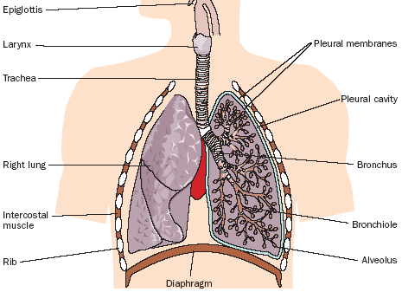

Mucus lining the trachea traps dust and bacteria and the beating of cilia on its surface move the mucus to the pharynx for swallowing The C-shaped rings of cartilage support the wall of the trachea.
The Alveoli are the sites of gas exchange and are surrounded with blood capillaries

The pleural membranes surround and protect the lungs permitting smooth moving of lungs.
The diaphragm and intercostal muscles are responsible for breathing.

Inspiration
Inspiration or breathing in is an active process because it involves muscle contraction. The diaphragm and intercostal muscles contract pulling the diaphragm downward and the ribcage up and out causing the chest cavity to expand so that air flows into the lungs.

Expiration
Breathing out is a passive process because it does not involve muscle contraction. The diaphragm and the intercostal muscles relax. The diaphragm returns to its dome shape and the ribs move back in, The volume of air in the lungs decreases causing an increase in the air pressure so the air flows out of the lungs

Inspired and Expired Air

Inspired and Expired Air Comparison
Gas + % | Inspired Air | Expired Air | Alteration
Nitrogen | 78% | 76% | No real change.
Oxygen | 20.8% | 15.3% | Reduced by about a quarter
Carbon Dioxide | 0.04% | 4.2% | Increased by about a hundred times.
Water Vapour | 1.2% | 6.1% | Increased about five times
Normal relaxed rhythmical breathing is controlled unconsciously by the medulla oblongata of the brain. A rise in blood CO₂ stimulates the medulla sending nerve impulses to the breathing muscles. The diaphragm and intercostal muscles contract and so air is breathed in. Nervous feedback from the inflating alveoli causes the medulla to switch of its stimulation. Inspiration stops and the lungs recoil causing expiration. Rapidly rising levels of CO₂ increase the rate of breathing. Exercise increases the production of CO₂ leading to an increase in the breathing rate.

Gas Exchange
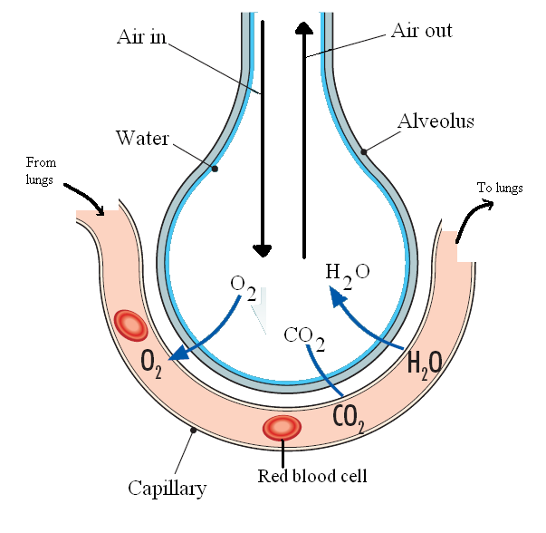Gas exchange happens at the alveoli. Oxygen diffuses from the air into the blood while carbon dioxide and water diffuse from the blood into the alveoli. Oxygen combines with the chemical haemoglobin in red blood cells and is carried to all parts of the body where it is used in respiration.
Gas Exchange Adaptations
- The moist surface of alveolus: enhances the uptake of O₂.
- Large Surface Area increases O₂ uptake.
- The cell membranes are thin and freely permeable to O₂ and CO₂.
- Slow Capillary Blood Flow allows time for complete oxygenation and excretion of CO₂.
Asthma
The most common type of asthma in children is allergic asthma. It is characterised by sensitivity towards allergens such as dust mites and air pollutants. It is also associated with allergic rhinitis (inflammation of the nasal passages) and eczema. Children usually grow out of this type of asthma by adolescence. The symptoms for adult and childhood asthma are similar and include:
- Shortness of breath - especially with exertion or at night.
- Wheezing - a whistling or hissing sound when breathing out.
- Coughing - may be chronic; usually worse at night and early morning.
- Chest tightness - may occur with or without the above symptoms.
The frequency of asthma attacks can be prevented by avoiding the source of allergens and is treated by inhalation of bronchodilators such as Ventolin © to widen the narrowed air passages. In severe cases, doctors may recommend using a Nebuliser. This machine is capable of delivering a high dose of asthma medication. by causing a jet of compressed air to flow over the drug, resulting in a cloud, which is breathed in through a mask

